Use case scenarios

add timeline

Preconditions:

1. Create mode has been chosen.

Description: The user chooses to create a timeline and then has the option to choose the start and end time of the timeline. As well as a title and a description.

Exceptions: Display mode does not give you the option to edit or create a timeline.

C:\Users\kiwi\AppData\Local\Microsoft\Windows\INetCache\Content.Word\Add Timeline.png

add event with duration

Preconditions:

1. Create mode has been chosen.
2. Timeline has been created.
3. The option to add an event with duration has been chosen.

Description: The user chooses a title, picture (optional), description, start- and –end time for the event.

Exceptions: Display mode does not give you the option to edit or create an event.

C:\Users\kiwi\AppData\Local\Microsoft\Windows\INetCache\Content.Word\add event with duration.png

modify event

Preconditions:

1. Timeline has been created.
2. Event with or without duration has been created.

Description: The user has the option to change: title, picture, description, start- and –end time (if not already added, user is able to add duration).

Exceptions: Display mode does not give you the option to edit or create an event.

C:\Users\kiwi\AppData\Local\Microsoft\Windows\INetCache\Content.Word\Modify event.png

add event without duration

Preconditions:

1. Create mode has been chosen.
2. Timeline has been created.
3. The option to add an event without duration has been chosen.

Description: The user chooses a title, picture (optional), and description for the event.

Exceptions: Display mode does not give you the option to edit or create an event.

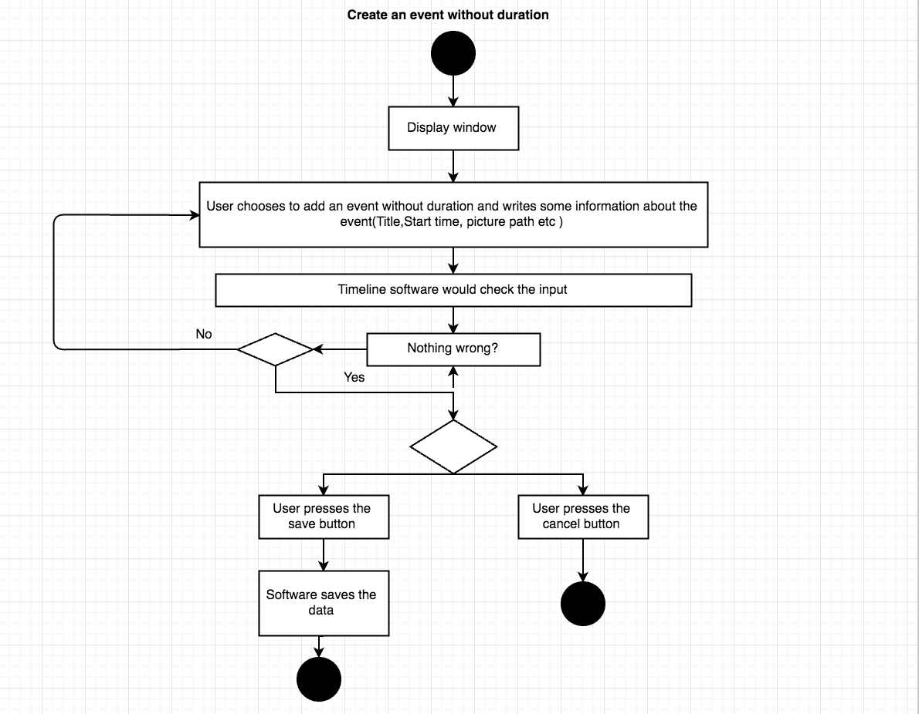

delete event

Preconditions:

1. Delete mode has been chosen.

Description: The user chooses to delete an event and remove all the information about this event.

Exceptions: Display mode does not give you the option to edit or create an event.

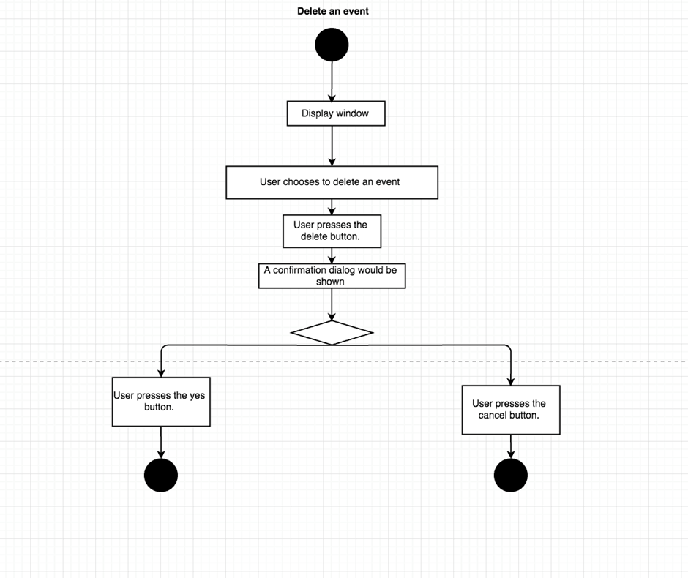

delete timeline

Preconditions:

1. Delete mode has been chosen.

Description: The user chooses to delete a timeline and remove all the information about this timeline (Start and end time, title, and description).

Exceptions: Display mode does not give you the option to edit or create an event.

